**R.VINOD REDDY, *Advocate***

**Standing Counsel for TSTRANSCO/TSSPDCL**

**H.No.8-2-684/4/31, Plot No.26, Anand Banjara,**

**Road No.12, Banjara Hills, Hyderabad – 500034**

*Ph: 040-23304342*

*9849041514*

**Advance Receipt**

*Date: 02-07-2018*

Received a sum of **Rs.10000/-** (Rupees Ten Thousand only) as per latest SP. O. O JS (IR & M) Ms. No. 24 dated 08-01-2018 from Assistant Divisional Engineer, Operation, Champapet, TSSPDCL, towards filing Counter affidavit in WP. No 15378 of 2018 filed by Sri Rama Plastic Industry before Hon’ble High Court at Hyderabad.

1) Legal Fee : Rs. 5000 =00

2) Filling Expenses : Rs. 5000=00

**Total : Rs. 10000=00**

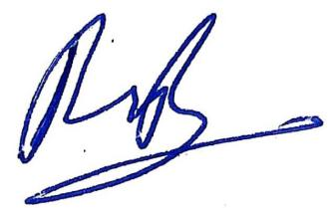

**(R.Vinod Reddy)**